**RESUME**

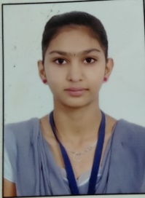

**DIKSHA BHARAMBE**

+91 7414994316

Email Id:- [dikshabharambe0101@gmail.com](mailto:dikshabharambe0101@gmail.com)

**OBJECTIVE**

To work with an organization where can learn new skills and increase my

abilities for the organizational goal as well as myself.

**EDUCATIONAL QUALIFICATION**

* Pursing MCA 1st year from IMR.
* Passed out BSc from Dhanaji Nana Mahavidyalaya in 2020
* Passed out 12th in 2018
* Passed out 10th in 2015

**Field of Interest**

* Basic knowledge of computer
* C, C++
* JAVA
* HTML,CSS(basic)

**WORK EXPERIENCE**

Fresher

**STRENGTH AND HOBBIES**

* Hard working
* Honest

**PERSONAL DETAILS**

Father’s Name :- Nandraj Supadu Bharambe

Date Of Birth :- 01-01-2001

Address :- Shri Ram Mandira parisar Amoda

Marital status :- single

Date:- ……………..

(Diksha Bharambe)